Unified Process

• Introduction

This report will cover the Unified Process Software model. It will give a description of the software development model. I will then compare and contrast the Unified Process with the Real World Software Process.
• Description of Process
- Overview of Process
The Unified Process is a popular iterative and incremental software process. It has been extensively revised and to form many different unified process models, including the Rational Unified Process (RUP) witch is the most extensively documented process witch is a trade mark of IBM. There is also the Enterprise Unified Process (EUP) witch is and extension of the Unified Process.
- History of Process
The Unified Process was modeled in the work that Ivar Jacobson did at Ericsson in 1960s, in 1987 Jacobson started his own company called Objectory AB, the company spent several years developing Objectory, which was both a process and a product. He over the next eight years Objectory AB rereleased two books, there was also a full web based version of the second book. Not long after that Rational Brought Objectory AB. The new company set out to improve the Unified Process. They created the Rational Objectory Process (ROP), in parallel with their expansion of the Unified Method into what became the Unified Modeling Language.
- Structure of Process 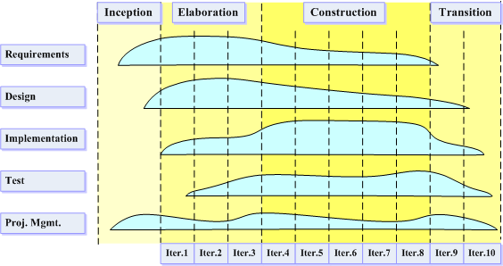
This image is licensed under the Creative Commons
Attribution ShareAlike License v. 2.5:
http://creativecommons.org/licenses/by-sa/2.5/

The structure clearly out lines the amount of work that should be implemented in each stage of the Software Development Process. Towards the end of each iteration, an example of the work is presented to the client. If the client is satisfied then the client will allow the project to continue. If not the Software Development Team repeat that stage until the client is happy with the standard of work produced. This allows the Client to detect problems before the final crucial deadline.
- Type of Projects for which the Process is Applicable
The standard Unified Process Model is some what out of date, however the more redefined processed such as; the Agile Unified Process (AUP), Basic Unified Process (BUP) etc are still being efexctivly usef by companies such as IBM and Microsoft.
- Breadth of Current Usage of Process
The variations of the Unified Process also lead the process to be used in many different situations. It is a loose instruction framework that is used to guide the production. This enables it to be customized to the project that will be undertaken, taking in to consideration the budget and the time constraints.
- Target Market of Process
The Unified Process and the redefined versions of the process have a large Target Market it includes anything from HTML development with 3 to 6 people and involve 3 to 6 months of development effort to Games Programming with Hundreds of people and years of on going development.
• Comparison with RWSP
- Similarities
Both Processes have an infinite number of iterations/phases.
- Differences
The various versions of the Unified Development process are generally aimed at large projects with some exceptions such as AUP and BUP. The RWSP is ideal for small-to-medium application development. The unified Process has no evaluation stage where as the RWSP dose. The RWSP just appends extra stages to complete the project the Unified Process actually repeats the stage until the client is happy with the product.
• Conclusion

Unified Process has now been replaced with numerous updated versions, this enables software development teams to pick and chose witch Unified Process Model they wish to follow.

• References

http://sky.fit.qut.edu.au/~rwsp/

http://www.awprofessional.com/articles/article.asp?p=24671&seqNum=3&rl=1

http://www.enterpriseunifiedprocess.com/

http://en.wikipedia.org/wiki/Unified_Process#Iterative_and_Incremental

Jacobson, Ivar, Grady Booch and James Rumbaugh. The Unified Software Development Process. Addison-Wesley, 1999.

• Appendix - Search Strategies

